**TERMS OF REFERENCE**

**FOR**

**BASELINE SURVEY OF NTFPs HARVESTING COMMUNITIES**

**UNDER**

**"SCALING CONSERVATION OF HIMALAYAN PLANTS AND FUNGI THROUGH SUSTAINABLE TRADE" PROJECT**

# Background

Nepal’s alpine Himalayan forests and rangelands are exceptional global biodiversity hotspots. Over 40 key wild plants and fungi are harvested and traded internationally, providing critical contributions to the incomes of the rural poor. These resources are being threatened by premature and overharvesting, climate change, unregulated trade and inequitable supply chains. Other challenges include - inadequate information on sustainable harvest volumes, inadequate approach to resource monitoring, and trade regulation. Despite these challenges, there are significant opportunities to improve both sustainability and trade of wild-harvested forest products, scaling up successful pilots in Nepal, and linking to major markets (e.g., India and China).

In order to address these challenges and tap the opportunities, TRAFFIC International, ANSAB, FECOFUN and other partners are implementing a UK Government’s Darwin Initiative project entitled "*Scaling conservation of Himalayan plants and fungi through sustainable trade*" in the Himalayan region of Nepal. This project aims to improve local livelihoods, elevate traditional knowledge, and strengthen national and regional approaches to sustainable biodiversity-based trade. At the impact level, the project will contribute to the sustainable management of Himalayan wild plants and fungi, with value chains that promote equitable trade, increase value addition, reduce poverty, and conserve species and ecologically fragile landscapes.

The project has five outputs: (i) Improved capacities and capabilities of stakeholders, especially women and excluded groups, for better conservation, resource management, and sustainable trade; (ii) Enhanced livelihoods for over 10,000 harvesters through long-term, sustainable, equitable trade in Non-Timber Forest Products (NTFPs)[1]; (iii) Sustainable management of over 110,000 hectares of high-altitude Himalayas through participatory land and species management and monitoring approaches; (iv) Establishment of sustainable Himalayan wild NTFP value chains from harvest to consumers based on traceable, certifiable production systems; and (v) Inclusion of provisions for sustainable, traceable trade in wild plants and fungi in trade agreements, and legal frameworks of Nepal, the region, and key importing countries.

This five-year project will be implemented in the Himalayan districts of Nepal (Figure 1, Annex 2), and a baseline data is needed to (i) measure the impact and progress in comparison with results of the final survey for project impacts’ evaluation, (ii) monitor project activities, and (iii) assess the impact of project. In this backdrop, ANSAB seeks consultancy service to establish the baseline values for the project, and requests the interested consultants to submit a brief proposal for carrying out this consultancy service.

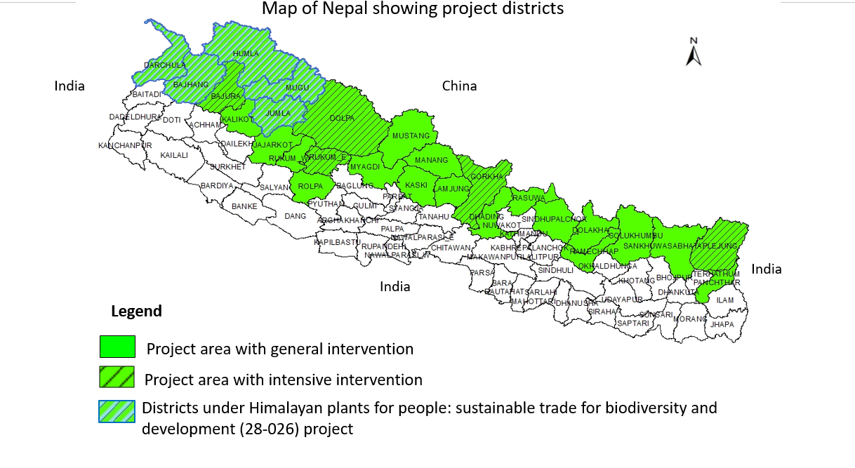

Figure 1: Project districts

# Objective of the work

The primary objective of this assignment is to conduct a baseline survey across ten Himalayan districts of Nepal (see Annex 2 for details on project districts), focusing on three key components: socio-economic status, livelihood and benefit-sharing strategies, and the sustainability of resources and NTFP harvesting practices.

# Scope of the work

The scope of work for the baseline study includes, but not limited to, the following:

* Analyse the general socio-economic characteristics of local communities and NTFP harvesters, including gender, ethnicity, age, and economic status
* Assess the livelihoods of local communities by examining sources of annual household income, food security, dependency on NTFPs, and contribution of NTFPs to total income
* Assess and quantify the employment generated by NTFPs within the project districts, focusing on specific Palikas and CFUGs
* Review forest management status and practices, particularly the incorporation of Sustainable Forest Management (SFM) and NTFP harvesting in Forest Operational Plans, and identity any gaps in the operational plans
* Document current and best management practices for NTFP harvesting, including indigenous knowledge on harvesting methods and NTFP usage
* Assess NTFP enterprises by analysing the supply chain and marketing activities in the study area
* Assess knowledge and practices, and readiness of communities for voluntary certification and participation
* Assess the management capabilities of CFUGs and FECOFUNs in forest and NTFP management
* Analyse the role of project stakeholders (Palikas, DFOs, Park Offices) in CITES compliance, biodiversity conservation, and the inclusion of NTFPs related activities in annual plans
* Analyse collected data/information and provide recommendations focusing on livelihood options, sustainable forest management and harvesting practices, benefit sharing, and value chain development

# Methodology

The following are the tentative methodological steps to be followed. The consultant, however, will need to prepare a detailed methodology incorporating these steps.

* Visit ANSAB to get acquainted with project, its objective, activities and the proposed work
* Review of existing documents (e.g., project documents, workplan, log-frame, brochures etc.) relevant to the scope of the study
* Review of existing secondary information, previous studies/assessment and reports relevant to the assignment
* Prepare a detail methodology including (i) sampling intensity viz. number and groups of respondents, Palikas and CFUGs to be sampled; (ii) questionnaires for household survey and key informant interviews; (iii) checklist for group discussion; and (iv) number of focus group discussions and key informant interviews as per the project document and project log-frame
* Share and circulate final version of questionnaires, tools and checklist and incorporate comments from ANSAB
* Prepare a detail plan of action/schedule covering orientation to enumerators, field work, data collection, analysis, interpretation, draft and final report preparation with concerned project staff
* Field visits in the project districts, Palikas, CFUGs for data collection and observations
* Consult local level stakeholders, including DFOs, Park Offices, FECOFUN district and Palika chapters, Palikas, District Chamber of Commerce and Industries, and local level NTFP-based enterprises in the process to understand the issues
* Share draft report and obtain comments/inputs and incorporate the same into final report
* Prepare final report in as standard format agreed with the project team and submit to ANSAB

# Deliverables

The output of the work includes a comprehensive baseline report. Following are the key deliverables of the work:

* Inception report with detailed methodological steps— sampling, questionnaire, checklist, workplan/timeline
* A draft report and power point presentation highlighting the preliminary results & recommendations for discussion with the project team
* A compiled version of final report
* An e-copy of raw data; and photographs of the baseline survey

# Timeframe

The consultancy period will be for three months, and will be effective from the date of agreement.

# Remuneration

The indicative budget for this consultancy work will be NRs 16,50,000 including tax. It includes consultants' fee including questionnaire preparation, data collection, travel, consultation, cost of enumerators, report preparation and submission in final form.

The travel and field expenses, will be provided following the approval of the inception report. A payment of 40% of the total fee will be made upon submission of the draft report, with the remaining balance disbursed after approval of the final report.

# Composition, qualification and experience of team

The team must possess a strong understanding of Nepal’s forestry sector, particularly in community forestry and NTFPs. The consultant shall provide the following personnel, each meeting the specified academic qualifications and professional experience:

**Team Leader**

*Qualifications:* Master’s degree in forestry, botany, agriculture, or environmental science, with a minimum of seven years of experience in Nepalese forestry, particularly in community forestry and NTFPs. Alternatively, a PhD with at least five years of relevant experience.

*Skills:* Proficiency in data analysis and interpretation, experience leading at least three baseline surveys for biodiversity-related projects, business fluency in English and Nepali, and excellent communication skills.

**Team Member**

*Qualifications*: Master’s degree in forestry, botany, or a related field with at least five years of experience in forestry and NTFPs.

*Skills:* Strong coordination skills, with knowledge of certification processes preferred but not required.

**Enumerators**

*Qualifications:* Minimum high school education in any discipline, with a strong understanding of local contexts. Preference for enumerators from the respective districts. The consultant does not need to provide names of enumerators at the proposal stage.

# Evaluation of the proposal

The proposals will be screened for their eligibility against the minimum requirements, mainly the composition, qualification and experience of the team. Proposals successfully fulfilling the eligibility assessment will undergo a qualitative assessment scored on the basis of the criteria presented in the following table:

|  |  |
| --- | --- |
| ***Evaluation criteria*** | ***Percentage point*** |
| Understanding of the ToR | 10 |
| Approach and methodology | 20 |
| Specific experience of the team in carrying out similar assignments | 50 |
| Financial allocation | 20 |

The financial details should be provided in the following format:

|  |  |  |  |  |  |
| --- | --- | --- | --- | --- | --- |
| ***Category*** | ***Items*** | ***Unit*** | ***Nos\**** | ***Rate (NPR)*** | ***Total (NPR)*** |
| Service Charge | Team leader | Person | 45 |  |  |
| Team member | Person | 40 |  |  |
| Enumerators (n=6) | Person | 90 |  |  |
| Travel Expenses | Airfare | Round trip |  |  |  |
| Jeep hire | Days |  |  |  |
| Local travel (taxi, bus for enumerators) | Lumpsum |  |  |  |
| Food and accommodation | Days |  |  |  |
| Field Expenses | Stationery, enumerators’ training, and FGD, KII costs and other meeting costs (specify each item in separate row) |  |  |  |  |
|  | | | | |  |

* Days are indicative only

# Application procedure

Interested consultants are requested to submit a brief proposal (including technical & financial details) outlining how you plan to achieve the objectives as stated in the TOR along with the updated detailed CV of the team leader and team member.

Qualified consultants may apply for this consultancy service by not later than December 1, 2024 by submitting the proposal along with a cover letter with the subject line as “Application for the consultancy service” to jobs@ansab.org.np. Short-listed consultants will be informed for further processing.

ANSAB deserves the right to cancel this call for consultancy service, or not to award any proposal.

# Annex 1: List of targeted species

1. Attis *Delphinium himalayae*
2. Guchi chyau *Morchella esculenta*
3. Jatamansi *Nardostachys jatamansi*
4. Kakoli *Fritillaria cirrhosa*
5. Kutki *Neopicrorhiza scrophulariiflora*
6. Padamchal *Rheum australe*
7. Panchaaule *Dactylorhiza hatagirea*
8. Satuwa *Paris polyphylla / Trillium govanianum*
9. Setakchini *Polygonatum cirrhifolium / P. verticillatum*
10. Sugandhawal *Valeriana jatamansi / V. hardwickei*
11. Yarsagumba *Ophiocordyceps sinensis*

# Annex 2: Districts and Palikas for project intervention

|  |  |  |  |
| --- | --- | --- | --- |
| ***Province*** | ***District*** | ***Palikas*** | ***Remarks on Palika Selection*** |
| Koshi | Taplejung | Sirijangha, Sidingba, Mikwakhola, Phaktanlung | Final selection |
| Gandaki | Gorkha | Dharche, Barpak Sulikot, Ajirkot, Chum-Nubri | Final selection |
| Lumbini | Rukum-East |  | TBD |
| Karnali | Dolpa | Kaike, Thuli Bheri, Tripura Sundari, Jagadulla | Tentative list |
| Jumla | Patarasi, Guhichaur, Tatopani | Tentative list |
| Mugu | Mugum Karmarong, Soru, Chayanath | Tentative list |
| Humla | Chankheli, Sarkegad, Kharpunath, Simkot | Tentative list |
| Sudurpaschim | Bajura | Himali, Budinanda, Gaumul | Tentative list |
| Bajhang |  | TBD |
| Darchula | Api Himal, Naugad, Marma, Byas | Tentative list |

1. Refer to annex 1 for the list of targeted NTFPs of the project