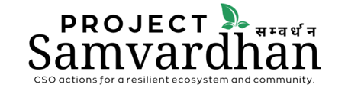

Call for Consultancy Services for
an assessment of biodiversity and ecosystem services in Banke and Bardiya districts

Annex I: Indicative format for the proposal

Technical details:
- Understanding of the ToR (1page)
- Proposed Approach and Methodology (2 pages)
- Description of Activities and Timeline (1 page)
- CV of the consultant highlighting the relevant experience

Financial details:
The budget should include all the budget items including tax and other associated costs, as appropriate.
SN | Particulars | Estimated man days /unit rate | Rate | Amount
1 | Consultant fee
2 | Consultations/meeting expenses
3 | Travel costs
4 | Food and accommodation
5 | Communication and stationery
6 | Others if any (specify)
 | Tax (if any)
 | Total

